MCj01495170000[1]**US History Unit 6 Study Guide:**

**World War II and the Beginning of the Cold War**

The Rise of Totalitarian Governments

1. What is a totalitarian government?

|  |  |  |
| --- | --- | --- |
| Country | Leader | Actions of the Nation Prior to the War |
| Germany |  |  |
| Soviet Union |  |  |
| Italy |  |  |
| Japan |  |  |
| Spain |  |  |

The Start of WWII in Europe

1. How did the terms of the treaty that ended WWI contribute to the problems that led to the start of WWII?
2. Why did the European nations choose to adopt a policy of appeasement in dealing with Hitler’s aggression in the 1930s?
3. What act by Hitler finally forced Britain and France to declare war on Germany?
4. What was the purpose of the Neutrality Acts passed in the United States in 1935, 1936, and 1937?
5. What was the purpose of the Lend Lease Act?
6. What event caused the United States to enter the war?

|  |  |
| --- | --- |
| **MAJOR AXIS POWERS** | |
| Country | Leader |
|  |  |
|  |  |
|  |  |

|  |  |
| --- | --- |
| **MAJOR ALLIED POWERS** | |
| Country | Leader |
|  |  |
|  |  |
|  |  |
|  |  |

Fighting the War

1. What is blitzkrieg?
2. What is a kamikaze?
3. What happened on “D-Day?”
4. What battle is considered the turning point of the war in Europe? (Germany’s last major offensive)
5. What battle is considered a turning point in the Pacific?
6. What ended WWII in the Pacific?
7. What was President Truman’s justification for dropping the atomic bombs?

The Home Front

1. Why did so many women join the workforce during World War II?

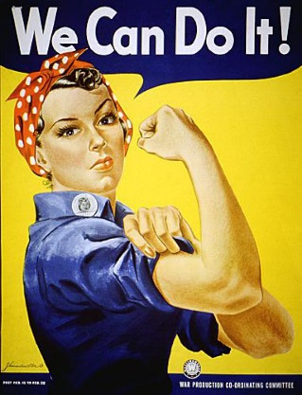

1. Who is this and what is the purpose of the poster?
2. Why did many African Americans move to Northern cities during the war? What is this movement officially called?
3. During the war, Americans were asked to ration certain some items. What does this mean and what types of products were rationed?
4. Why did the United States intern people of Japanese descendent living on the west coast?
5. How did the ruling in *Korematsu v. United States* justify Japanese internment?
6. In 1940, how did President Franklin Roosevelt break with presidential precedent?

Anti-Semitism and the Holocaust

1. What is genocide?
2. Why are the Nuremburg Trials significant?
3. List at least three stages of Hitler’s Anti-Semitism in the Holocuast. In other words, what were three events Hitler did leading up to the mass exterminations.